Media Release | New Award celebrated, but unfunded.

On 28 February 2017, the Queensland Industrial Relations Commission (QIRC) published the new Queensland Local Government Industry Award - State 2017 which will now regulate the employment conditions and entitlements of local government workers in Queensland.

In 2015, Treasurer, and the then Minister for Employment and Industrial Relations and Minister for Aboriginal and Torres Strait Islander Partnerships, the Honorable Curtis Pitt MP, suspended award modernisation processes to allow consultation with key stakeholders, and instructed the QIRC to review the previous Queensland Local Government Industry Award – State 2014 regulating Local Government, with a view to “restoring conditions of local Council workers”.

On 13 July 2016, the then Minister for Employment and Industrial Relations, Minister for Racing and Minister for Multicultural Affairs, the Honourable Grace Grace MP, said “Conditions including sick leave, overtime and locality allowances were stripped away under the LNP, leaving thousands of council workers worse off.”

We commend the new Award published by the QIRC and the actions of the State Government. As the largest employer for the Torres Strait region, the new Award is one step closer to providing a fairer standard of living for its constituents.

However, this accomplishment is futile without funding. As the State government directed QIRC to reintroduce these conditions, including locality allowances – they bear responsibility for funding its implementation.

As the new Award stands, the projected liability to the Torres Strait Island Regional Council for the 2017/18 financial year would be in the order of $1.25M. This is if we only paid our ‘white-collar’ office workers as the new Award prescribes.

However, this would completely ignore a third of TSIRC’s staff who are ‘blue-collar’ workers, working outdoors across our communities. All TSIRC staff are subject to exactly the same pressures of cost of living in remote Indigenous communities.

Locality allowance is an entitlement which should be afforded to all of our employees – regardless of whether they work indoors or outdoors. Applying this new locality allowance to all of our workers fairly and equitably will cost us in the order of $2.5M in the 2017/18 financial year. This will put, on average, an extra $8,600 into the pockets of our workers in 17/18 (or $334 per fortnight). This will go a long way to addressing the cost of living challenges faced in our remote communities. For people who are paying up to three times the price for food, petrol and transport as other Queenslanders, this will be a small reprieve on crippling financial insecurity.

After being forced to cut to the bone its projected 17/18 budget to fill a $2.7M Federal funding reduction in water, waste, and healthy living. TSIRC still forecasts a modest operating surplus of $12k, whilst still maintaining its current staffing levels and frontline service delivery.

However, there have been no additional funds provided by the State Government to implement the Minister’s direction to reintroduce the new allowances.

Our communities experience the highest living costs in Australia. We know that access and affordability for fresh food, employment and education opportunities and financial equality significantly improves Aboriginal and Torres Strait Islanders health and life expectancy.

Funding real actions will Close the Gap for our people. This new announcement to reinstate the locality allowance is a great start - but it comes at a great cost. If it is not funded immediately by the State government, it has the potential to cripple TSIRC, resulting in possible mass redundancies.

We urge the State Government to provide the $2.5M they have rightfully advocated for, so that our employees can realise a better quality of life.

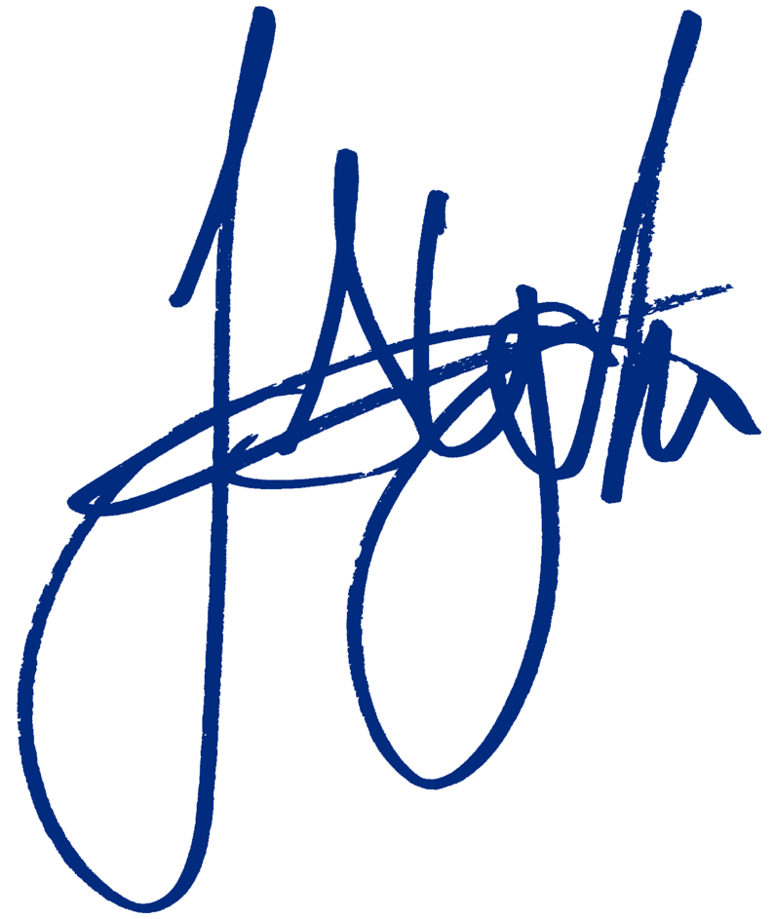
Mayor Fred Gela

For further queries please contact Manager Engagement, Bianca Barling-Seden through Bianca.Barling-Seden@tsirc.qld.gov.au or 0400 856 333.

